## Tmotor-Alpha Introduction

Tmotor-Alpha flight controller, running the brand-new Alpha firmware, has the following features:

* 1. Ability to utilize high-speed ESC protocols up to the Dshot2400 to provide a smoother, more linear throttle response as well as better prop-wash handling.
  2. In addition, the redesigned filtering algorithm can better handle the mechanical resonance of the frame and well stabilize the flight attitude in the event of damaged motor balance and bent propeller blades.
  3. Easy to build up, there are DJI AirUnit socket and receiver socket for solder-free installation on HD version.
  4. Easy to tune, using OSD to complete all the adjustment process (or using web configurator, no need to download)
  5. Easy setup, automatic recognition of receiver protocol, and built-in analog video transmission table.
  6. Both Analog and HD version have 5V 3 A BEC, and the HD version excludes 12 V 1.5A BEC (designed according to the standard of BF flight controller).
  7. The chord motor beeps, stronger penetration, convenient for finding craft after crashed.

## ESC motor and VTX companions

Based on months of actual testing, we suggest:

* 1. ESC premieres the T-motor P60A v2, which supports the Dshot2400, providing faster motor response and more linear throttle power.
  2. On motor side, the P2306v3 (1750-2080 KV) is preferred, and the F60 Pro V series as well.
  3. DJI O3 or HD Zero is preferred for digital video transmission, which can directly display all OSD information through CANVAS mode for easy parameter tuning.
  4. If using the O2 DJI AirUnit or Vista, you can also use the OSD to tune the parameters after enabling the CANVAS mode by installing WTFOS.
  5. Analog video transmission can be directly adjusted using analog OSD. (On Analog Version only, due to Excluded OSD MCU)

## Prerequisites for installation

Frame:

Can be pair with common frame, which has a mounting size of 30.5x30.5 M3 and a height of 18mm or more.

Assembly Cautions:

1. It is recommended to fix the stack screws with nuts onto frame to ensure that the stack does not shake relative to the frame.
2. Choose a shock absorber column/rig of the appropriate size to fix the flight controller and the ESC to ensure that the flight controller and the ESC are not in direct contact.
3. The flight controller pad layout has been optimized, do not route from the components above or below the flight controller, it is recommended to route the wire outward or directly use the socket for solder-free installation, when using the socket installation, please pay attention to the wire order.
4. The pad interface is defined as follows,

HD Version:



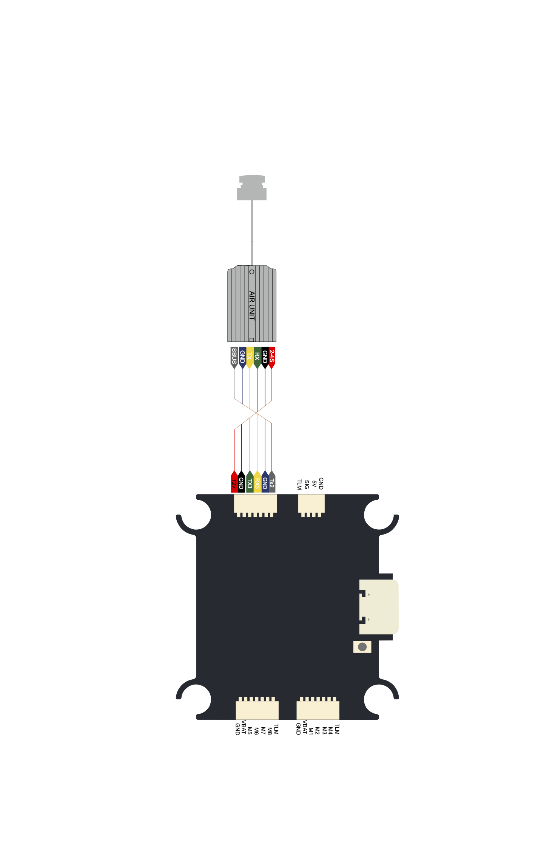

Analog Version

Please note that if receiver is connected by soldering, the TX of the receiver must be connected to the SIG pad, and the RX must be connected to the TLM pad.

For analog video transmission, the VTX Control RX must be connected to the TX3 or TX4 pad of the flight controller, and the video input must be connected to the VO pad; The video output from analog camera must be connected to the VI pad.

In the case of digital video transmission, the RX line must be connected to the TX3 or TX4 pad of the flight controller, and the TX line must be connected to the corresponding RX pad.

Setup before first flight

1. CONNECTING AND UPGRADING FIRMWARE: TO USE ALPHA FLIGHT CONTROLLERS FOR THE FIRST TIME, YOU NEED TO USE ALPHA CONFIGURATOR FOR SETUP:

(URL <https://gui.fettec.net/FC/index.html>, recommended to open using Google Chrome).

Click Open port, select the corresponding serial port and connect.

We recommend upgrade the firmware at first, as the latest firmware can provide a better experience.

Click Firmware, select new firmware to flash after connecting, and select the latest version of FETtec ALPHA FW.

After flashing the firmware, reconnect to the flight controller according to the prompts, and click Exit firmware mode to exit the flashing firmware mode to complete the upgrade.

1. Set the flight controller orientation: The default orientation of the Alpha flight controller is gyroscope facing up, that is, the component side is facing up, the pad welding side is facing down, and the esc sockets are facing forward.

If you want the logo facing up, you should set FC UPSIDE DOWN to YES on

SETTINGS > FC SETUP > FC ORIENTATION.

Then click SAVE to save configuration, remember doing this after every configuration change.

Once set, you can select the Signals tab at the top of the page, scroll to the bottom 3D model, click the calibrate accelerometer to calibrate the accelerometer, and then slowly turn the craft to check if the flight controller orientation is set correctly.

1. Set up the ESC protocol: use P60A v2 which supports the Dshot2400 as an example:

In SETTINGS > ESC+MOTOR SETUP, CLICK ESC SIG. TYPE, change it to DS2400, and click SAVE, save the settings and power up the flight controller again to complete the setup.

1. Set the order and direction of the motors: Be sure to remove propeller for safety!

The motor order of the Alpha flight controller is completely different from the BF.

By default its left front motor is No. 1 motor, right front is No. 2, right rear is No. 3, and left rear is No. 4 (show the default azimuth map)

You can change motor mapping according to the actual installation of the motor on the ESC, in

SETTINGS > ESC+MOTOR SETUP > OUTPUT MAP.

In addition, if you use the 8p to 7p cable included with the flight controller, you can also select BF 4 in 1 ESC default in Presets blank for quick setup. Similarly, click SAVE to save after setting.

The direction of each motor is then set in

SETTINGS > ESC+MOTOR SETUP > DSHOT SETUP.

Once set up, you can test the motor in

SETTINGS > ESC+MOTOR SETUP > MOTOR TEST.

Then set Propeller rotation direction (Yaw) in

SETTINGS > ESC+MOTOR SETUP > PROP DIR.

set IN (normal) or OUT (reverse) according to the actual direction of the motors.

1. Set the remote channel: When the receiver is powered on and the remote is paired, the Alpha flight controller can automatically recognize the receiver protocol.
2. In the RC Channels tab of Signals page, you can view the definition of the remote channel of the current flight controller, and then set the corresponding channel in SETTING > RC SETUP then click SAVE to save.
3. Go back to the Signals page and check if the channels for arm, throttle, roll, pitch, and yaw are correctly set.
4. SET UP VIDEO TRANSMISSION:

for digital video transmission,

change MSP Port in

SETTINGS > FC SETUP > SERIAL,

to serial3 or 4 according to the serial pad connected to your digital VTX then save by clicking SAVE.

for analog video transmission,

set VTX SERIAL to SERIAL according to the serial pad connected to your analog VTX, then set the Control protocol according to the protocol used by your analog video transmission, and then set Armed (mW) according to the maximum power of your i analog video transmission, and finally click SAVE to save.

(After testing, Alpha flight controller's adaptive VTX power function and automatic VTX table function are available on TBS VTXs, and more other VTX compatibility is under development.)

1. After the above settings are completed, your Alpha is ready to take off, please test whether the aircraft can take off normally by visual flight before the actual fpv flight.

飞行调参教学

在成功起飞Alpha飞机后，您会发现默认参数并不是很好飞，大动作结束会有回弹，同时也存在一些洗桨的情况。

为了改善飞行性能，我们需要依次调节TUNING和PID。

下面，我将依次介绍TUNING下每一项的含义，和他们对飞行性能产生的影响。

首先是 Throttle PID attenuation，这是PID参数随油门衰减的比例。

这个选项可以抑制穿越机大油门下发生的高频抖动，通常我们保持默认即可。

接下来是D Term tuning，这是关于PID中D值运算方式的微调。

Setpoint weight，影响的是打杆输入在D值运算中的权重。

默认设置为1.0 可以迅速抑制洗桨，你也可以根据手感的需要，略微减少这一项的值，减少该值会使穿越机不那么跟手，同时提升对硬件损坏的宽容度。

Frequency depth，影响D值运算的动态范围，更小的值会使不同速度打杆受到的D值影响一致，并略微减少洗桨。更大的值会使小幅度打杆更加灵敏，但会稍微增加洗桨。根据手感需求调节。

P Term LPF strength，影响陀螺仪滤波强度，更低的值会带来更小的相位延迟，以抑制洗桨；更高的值能保证机况较差的穿越机能飞。

Yaw jump reduction，偏航轴稳定，在部分大动作结束后偏航轴可能会出现漂移，这是因为飞机动力过猛且四个电机的KV无法做到完全相同。

Throttle punch I boost，大油门姿态增稳，在油门突变时升高I值以抑制姿态漂移。这种情况的发生是因为飞机的推力中心和重心通常不在一个点，在推力突然增加时会发生类似点头的问题。

Strength：增强程度

Inc. Speed:增压速度

Dec. Speed:回落速度

Frame strength，机架强度，利用算法平滑电机油门信号，保证较软的机架能够正常飞行。

PID就是我们很熟悉的PID，后面我会介绍一个非常简单的手动调整的方法，无需黑匣子和非常专业的知识即可轻松调到好飞。

接下来是调参实战教学，对于一般的五寸机来说，油门TPA我们保持默认，D Term tuning中的setpoint weight也保持默认，而Frequency depth，对于一般的机架来说，我们可以设置在0.55-0.75，机架越好就设置得越低。P Term LPF，亲测拉到0.4就可以很好的抑制洗桨了。至于Yaw jump reduction，应该设置为默认值的2倍，即0.0150。接下来就是很重要的Throttle punch I boost，强度设置为3到4之间，Inc. Speed稍微增加到0.09-0.1，其余保持默认。

机架强化建议设置为MEDIUM或着HIGH。

然后我们通过听和看来调整PID。

。

首选我们增加D值，每次最多上调1。当我们飞行时听见螺旋桨声音变得不干净，同时画面开始有高频率抖动时再以0.2进行回调直至正常飞行，我们就得到了当前条件下D值的上限。

其次，我们调整P值，每次最多上调0.1.根据你打杆时的跟手程度增加或减少P即可，如果你在打杆结束后有快速的回弹，或者飞行过程中螺旋桨的声音变得不干净，则说明当前的P值太高

至于I值，我们应该在空中做零油门下落或者倒飞的动作，观察油门全收时飞机会不会晃动，如果会晃动，就谨慎低增加它，0.001为一步，直到飞机刚好不会晃动；如果打杆后有回弹，就减少他，直至飞机不会晃动。

过高的I值会使飞机反应变慢，在大动作结束时产生无法消除的缓慢回弹。

自此，Alpha穿越机就调好了，开始享受飞行吧。